Exercises – LOGIC CIRCUITS
Exercise 1.
Write the corresponding Boolean function associated to the following logic circuit, then simplify it and draw a simplified equivalent circuit using only basic gates:

1. | x  z  y
2. | x  z  y
3. | x  z  y
4. | x  z  y
5. | x  z  y
6. | x  z  y
7. | x  z  y
8. | x  z  y

Exercise 2.
For each of the following Boolean functions draw the corresponding logic circuit using derived gates, simplify the function and draw the logic circuits associated to all simplified forms of the initial function using only basic gates.
- f₁(x, y, z) = x (y ⊕ z) ∨ y (x ⊕ z) ∨ x ( ¯y ↓ ¯z) ∨ (x ↓ y)¯z ; | - f₂(x, y, z) = x (y↑z) ∨ ¯x (¯y ⊕ z) ∨ y (¯x ⊕ ¯z);
- f₃(x, y, z) = x (¯y ⊕ z) ∨ y (¯x ⊕ z) ∨ ¯ x ( ¯y ↓ z) ∨ (¯x ↓ y) z ; | - f₄(x, y, z) = ¯x (y↑ ¯z) ∨ x (¯y ⊕ z) ∨ ¯y (¯x ⊕ z) ;
- f₅(x, y, z) = ¯x (y ⊕ ¯z) ∨ ¯y (x ⊕ z) ∨ ¯x ( y ↓z) ∨ (¯x ↓ y) ¯z ; | - f₆(x, y, z) = x ( ¯y↑ ¯z) ∨ ¯x (y ⊕ z) ∨ ¯y (¯x ⊕ z);
- f₇(x, y, z) = x (y ⊕ ¯z) ∨ y (¯x ⊕ z) ∨ x (y ↓ z) ∨ (x ↓ y) ¯z ; | - f₈(x, y, z) = x ( ¯y↑z) ∨ ¯x ( ¯y ⊕ z) ∨ y ( x ⊕ ¯z) .

Exercise 3.
Draw a logic circuit having 3 input wires and containing all basic and derived gates. Write the corresponding Boolean function, simplify it and then draw a simplified circuit equivalent to the initial one.
Exercise 4.
Write a Boolean function of 4 variables given by its truth table, simplify it and draw the logic circuits corresponding to all its simplified forms.
Exercise 5.
Electronic display of the decimal digits using 7 segments (LEDs):

The combinational circuit having the functionality described above has as inputs 4 variables and as outputs 7 functions corresponding to the segments.
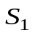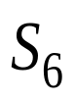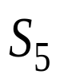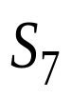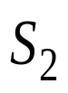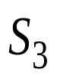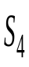 | 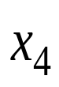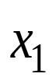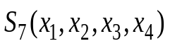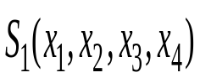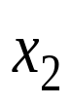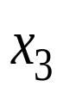  7 segments display
The combinations of 4 binary digits which do not correspond to a decimal digit will generate an emission of light only for the segment 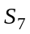.

 | inputs |  |  |  | outputs
Decimal digit | 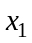 | 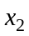 | 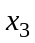 | 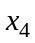 | 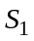 | 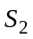 | 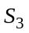 | 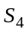 | 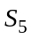 | 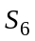
 | 0 | 0 | 0 | 0 | 1 | 1 | 1 | 1 | 1 | 1 | 0
 | 0 | 0 | 0 | 1 | 0 | 0 | 0 | 0 | 1 | 1 | 0
 | 0 | 0 | 1 | 0 | 1 | 0 | 1 | 1 | 0 | 1 | 1
 | 0 | 0 | 1 | 1 | 1 | 0 | 0 | 1 | 1 | 1 | 1
 | 0 | 1 | 0 | 0 | 0 | 1 | 0 | 0 | 1 | 1 | 1
 | 0 | 1 | 0 | 1 | 1 | 1 | 0 | 1 | 1 | 0 | 1
 | 0 | 1 | 1 | 0 | 1 | 1 | 1 | 1 | 1 | 0 | 1
 | 0 | 1 | 1 | 1 | 1 | 0 | 0 | 0 | 1 | 1 | 0
 | 1 | 0 | 0 | 0 | 1 | 1 | 1 | 1 | 1 | 1 | 1
 | 1 | 0 | 0 | 1 | 1 | 1 | 0 | 1 | 1 | 1 | 1
 | 1 | 0 | 1 | 0 | 0 | 0 | 0 | 0 | 0 | 0 | 1
 | 1 | 0 | 1 | 1 | 0 | 0 | 0 | 0 | 0 | 0 | 1
 | 1 | 1 | 0 | 0 | 0 | 0 | 0 | 0 | 0 | 0 | 1
 | 1 | 1 | 0 | 1 | 0 | 0 | 0 | 0 | 0 | 0 | 1
 | 1 | 1 | 1 | 0 | 0 | 0 | 0 | 0 | 0 | 0 | 1
 | 1 | 1 | 1 | 1 | 0 | 0 | 0 | 0 | 0 | 0 | 1

- Draw the simplified logic circuit of S₁ using only NAND gates.
- Draw the simplified logic circuit of S₁ using only NOR gates.
- Draw the simplified logic circuit of S₂ using only NAND gates.
- Draw the simplified logic circuit of S₂ using only NOR gates.
- Draw the simplified logic circuit of S₄ using only NAND gates.
- Draw the simplified logic circuit of S₄ using only NOR gates.
- Draw the simplified logic circuit of S₅ using only NAND gates.
- Draw the simplified logic circuit of S₅ using only NOR gates.
- Draw the simplified logic circuit of S₆ using only NAND gates.
- Draw the simplified logic circuit of S₆ using only NOR gates.
- Draw the simplified logic circuit of S₇ using only NAND gates.
- Draw the simplified logic circuit of S₇ using only NOR gates.

Exercise 6.
Binary codes are used to represent the ten decimal digits on 4 bits. There exist weighted codes and unweighted codes. In a weighted code each binary digit has a ‘weight’ and the decimal value is obtained as the weighted sum of all 4 bits.
BCD - Binary Coded Decimal is an example of a weighted code, with the weights for the digits: 8,4,2,1 (from the most significant digit to the least significant one).
The most used unweighted codes are Excess 3 (obtained by adding ‘0011’ to each BCD word) and the Gray code (a cyclic code with the property that all the successive words differ by one single digit).

The table below provides the BCD, Excess 3 code and Gray code on 4 bits.

Decimal value | BCD |  |  |  | Excess 3 |  |  |  | Gray code
Decimal value | b₃  ₈ | b₂  ₄ | b₁  ₂ | b₀  ₁ | e₃ | e₂ | e₁ | e₀ | g₃ | g₂ | g₁ | g₀
0 | 0 | 0 | 0 | 0 | 0 | 0 | 1 | 1 | 0 | 0 | 0 | 0
1 | 0 | 0 | 0 | 1 | 0 | 1 | 0 | 0 | 0 | 0 | 0 | 1
2 | 0 | 0 | 1 | 0 | 0 | 1 | 0 | 1 | 0 | 0 | 1 | 1
3 | 0 | 0 | 1 | 1 | 0 | 1 | 1 | 0 | 0 | 0 | 1 | 0
4 | 0 | 1 | 0 | 0 | 0 | 1 | 1 | 1 | 0 | 1 | 1 | 0
5 | 0 | 1 | 0 | 1 | 1 | 0 | 0 | 0 | 0 | 1 | 1 | 1
6 | 0 | 1 | 1 | 0 | 1 | 0 | 0 | 1 | 0 | 1 | 0 | 1
7 | 0 | 1 | 1 | 1 | 1 | 0 | 1 | 0 | 0 | 1 | 0 | 0
8 | 1 | 0 | 0 | 0 | 1 | 0 | 1 | 1 | 1 | 1 | 0 | 0
9 | 1 | 0 | 0 | 1 | 1 | 1 | 0 | 0 | 1 | 1 | 0 | 1
10 | 1 | 0 | 1 | 0 | - | - | - | - | 1 | 1 | 1 | 1
11 | 1 | 0 | 1 | 1 | - | - | - | - | 1 | 1 | 1 | 0
12 | 1 | 1 | 0 | 0 | - | - | - | - | 1 | 0 | 1 | 0
13 | 1 | 1 | 0 | 1 | - | - | - | - | 1 | 0 | 1 | 1
14 | 1 | 1 | 1 | 0 | - | - | - | - | 1 | 0 | 0 | 1
15 | 1 | 1 | 1 | 1 | - | - | - | - | 1 | 0 | 0 | 0

Implement the combinational circuits for converting:
- from BCD to Excess 3 code;  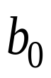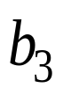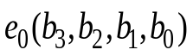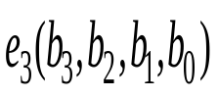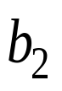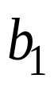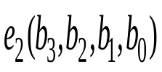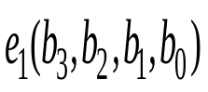 | - from BCD to Gray code;  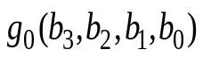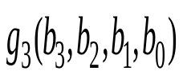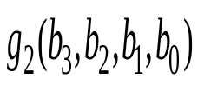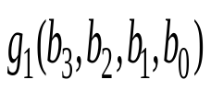
- from Excess 3 code to BCD;  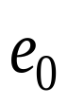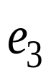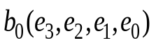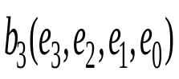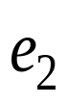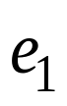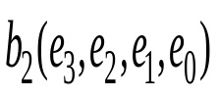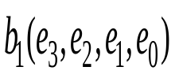 | - from Excess 3 code to Gray code;  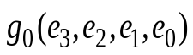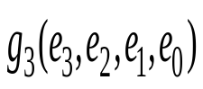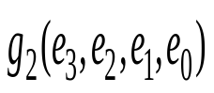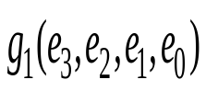
- from Gray code to BCD;  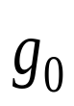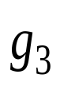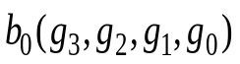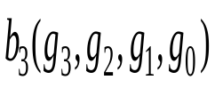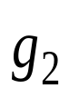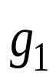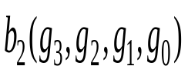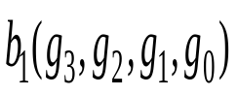 | - from Gray code to Excess 3 code;  